EXPERIMENT 4
DATE:
Analysis of Continuous Charge Distribution in electric field. To find the (i) line charge density, (ii) Surface charge density and (iii) Volume charge density for any specific (a) line, (b) surface or (c) volume.
Aim:
To write program for continuous Charge Distribution in electric field. The different types of charge density are (a) Linear Charge Density, (b) Surface Charge Density, (c) Volume Charge Density using MATLAB.
Software required:
•MATLAB (R2018 or later)
Program:
Test case (i) Determination of line, surface and volume charge density for given charge, length and radius
clc;
clear;
q=input("Enter the charge value is:");
l=input("Enter the length value is:");
% Line charge density
rho_l = q/l;
disp('the line charge density is');
disp(rho_l);
% Surface charge density
r=input("Enter the radius value is:");
rho_s = q/(4*pi*r^2);
disp('the surface charge density is');
disp(rho_s);
% Volume charge density
rho_v = q/((4/3)*pi*r^3);
disp('the volume charge density is');
disp(rho_v);
% Plot
x = linspace(0.1,10,50);
y = rho_l./x;
z = rho_s./(x.^2);
v = rho_v./(x.^3);
figure;
subplot(1,3,1);
plot(x,y,'LineWidth',2);
title('Line charge density');
xlabel('Length');
subplot(1,3,2);
plot(x,z,'LineWidth',2);
title('Surface charge density');
xlabel('Radius');
subplot(1,3,3);
plot(x,v,'LineWidth',2);
title('Volume charge density'); xlabel('Radius');
Output:-
Enter the charge value is: 2e-2
Enter the length value is: 1e-3
the line charge density is 20
Enter the radius value is: 2
the surface charge density is
3.98e-4
the volume charge density is
5.97e-4
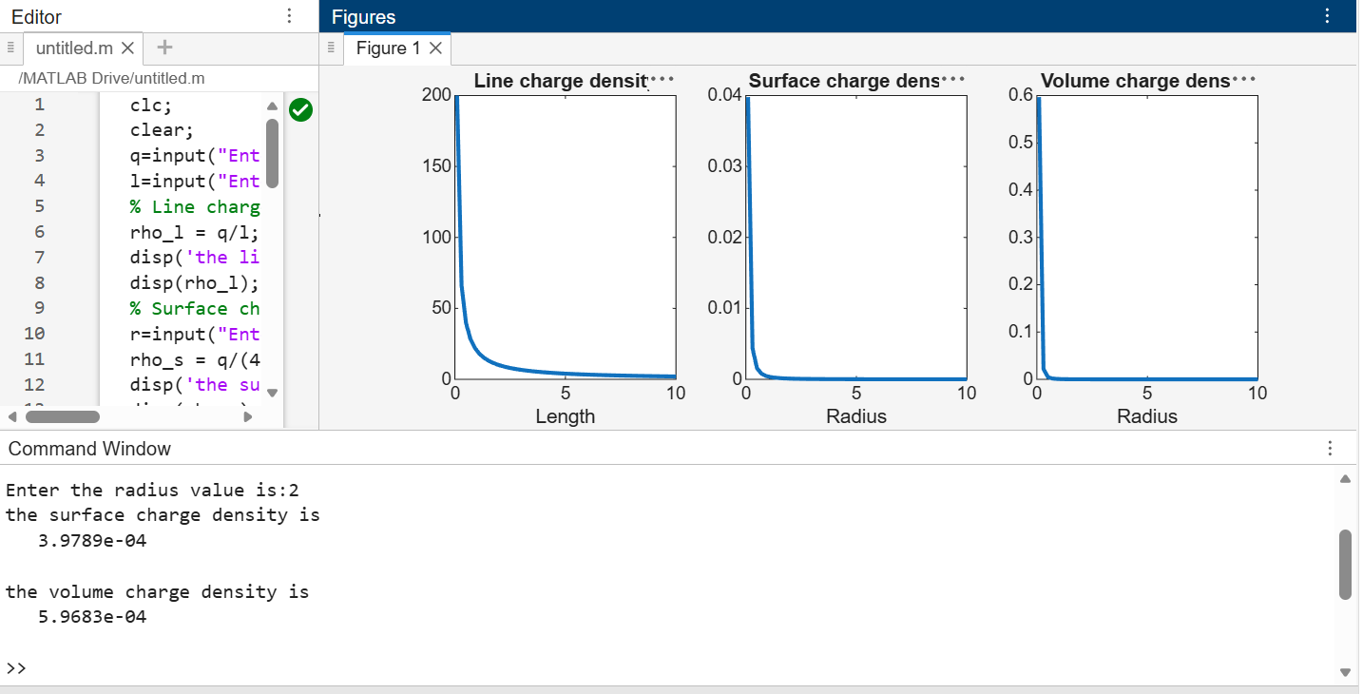
Test case (ii) A long wire of length L = 10 m carries a uniform charge of Q = 50 μC.
Calculate the line charge density and plot electric field variation
Program:
clc;
L = 10;
Q = 50e-6;
lambda = Q/L;
disp("Line charge density:");
disp(lambda);
r = linspace(0.1,5,100);
k = 9e9;
E = k*lambda./r;
plot(r,E,'LineWidth',2);
xlabel('Distance (m)');
ylabel('Electric Field (N/C)');
title('Electric Field due to Line Charge');

Output:-
• Line charge density = 5×10−6 C/m
• Electric field decreases with distance
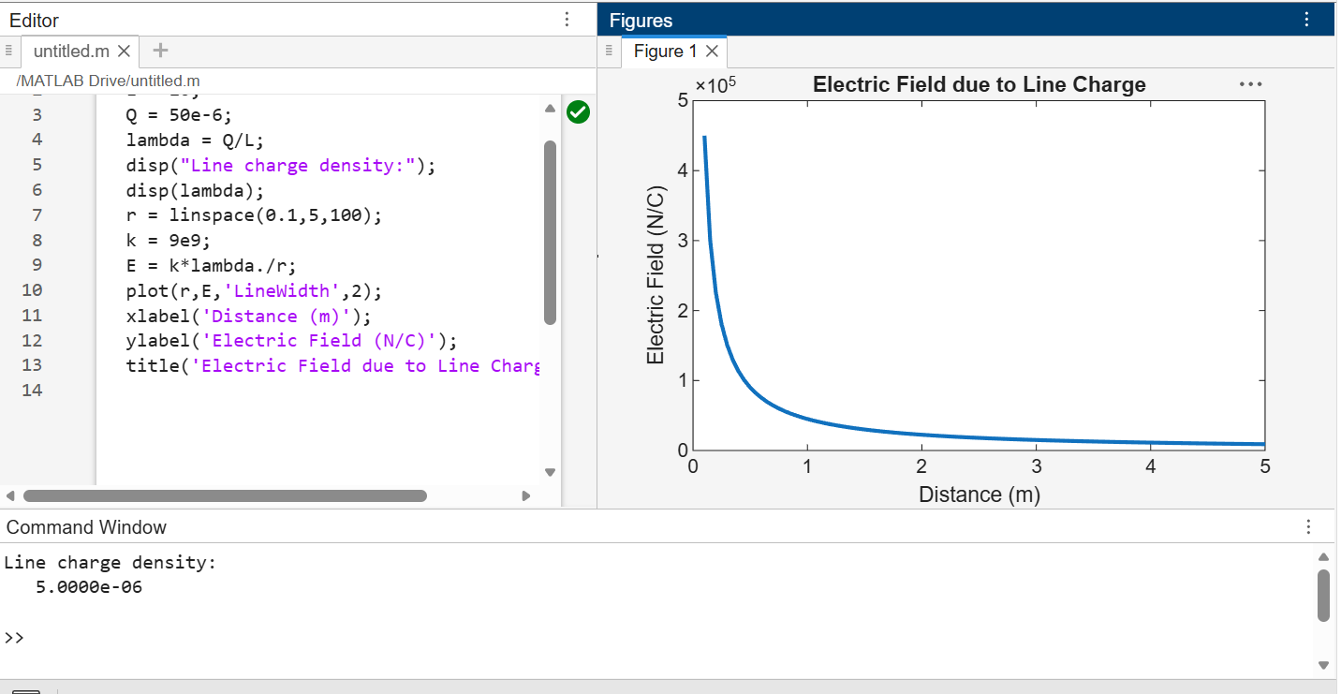
Test case (iii) A uniformly charged disk of radius R = 0.5 m with total charge Q = 10 μC.
Calculate surface charge density and electric field
Program:
clc;
R = 0.5;
Q = 10e-6;
A = pi*R^2;
sigma = Q/A;
disp("Surface charge density:");
disp(sigma);
z = linspace(0.1,2,100);
k = 9e9;
E = (k*sigma*R^2)./(2*(z.^2 + R^2).^(3/2));
plot(z,E,'LineWidth',2);
xlabel('Distance (m)');
ylabel('Electric Field (N/C)');
title('Electric Field due to Charged Disk');
Output:-
• Surface charge density = 1.2732e-05
• Electric field decreases non-linearly

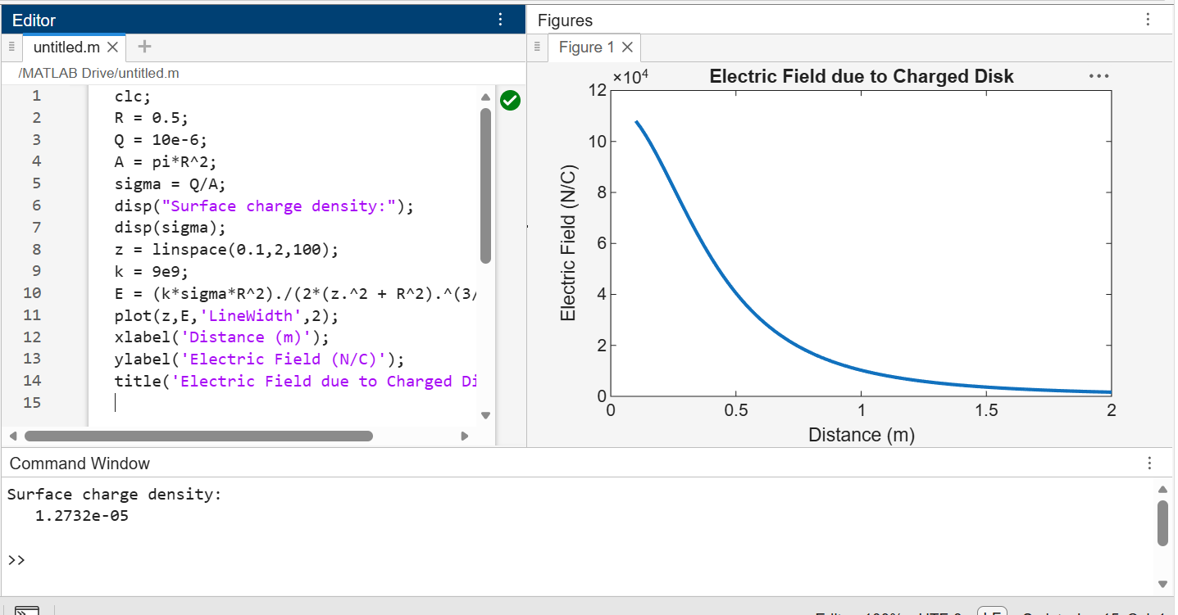
Test case (iv) A uniformly charged sphere of radius R = 2 m with total charge Q = 20
μC. Calculate volume charge density and electric field inside and outside 3
Program:
clc;
R = 2;
Q = 20e-6;
V = (4/3)*pi*R^3;
rho = Q/V;
disp("Volume charge density:");
disp(rho);
r = linspace(0.1,3,100);
k = 9e9;
E_inside = (k*rho.*r)/3;
E_outside = k*Q./(r.^2);
plot(r,E_inside,'LineWidth',2); hold on;
plot(r,E_outside,'LineWidth',2);
xlabel('Distance (m)');
ylabel('Electric Field (N/C)');
title('Electric Field inside and outside sphere');
legend('Inside','Outside');
Output:
• Volume charge density: 5.9683e-07
• Inside: linear variation
• Outside: inverse square variation

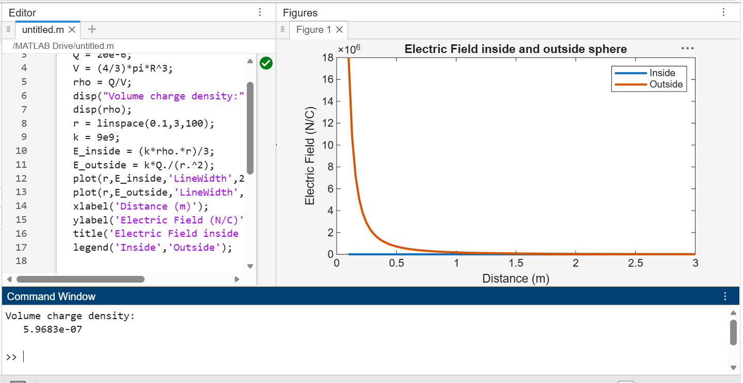

Parameters | Observed/Simulated Result | Theoretical Result | Error Difference
q = 2e-2, l = 1e-3 | ρl = 20 C/m | ρl = 20 C/m | Δ ≈ 0
q = 2e-2, r = 2 | ρs = 3.98 × 10⁻⁴ C/m² | ρs = 3.98 × 10⁻⁴ C/m² | Δ ≈ 0
q = 2e-2, r = 2 | ρv = 5.97 × 10⁻⁴ C/m³ | ρv = 5.97 × 10⁻⁴ C/m³ | Δ ≈ 0
Q = 50 μC, L = 10 m | λ = 5 × 10⁻⁶ C/m | λ = 5 × 10⁻⁶ C/m | Δ ≈ 0
Q = 10 μC, R = 0.5 | σ = 1.27 × 10⁻⁵ C/m² | σ = 1.27 × 10⁻⁵ C/m² | Δ ≈ 0
Q = 20 μC, R = 2 | ρ = 5.97 × 10⁻⁷ C/m³ | ρ = 5.97 × 10⁻⁷ C/m³ | Δ ≈ 0

Result :
Thus, the program was verified for continuous Charge Distribution in electric field. The
different types of charge density there are
(a) Linear Charge Density
(b) Surface Charge Density
(c) Volume Charge Density using MATLAB was successfully.

